Hayfield School

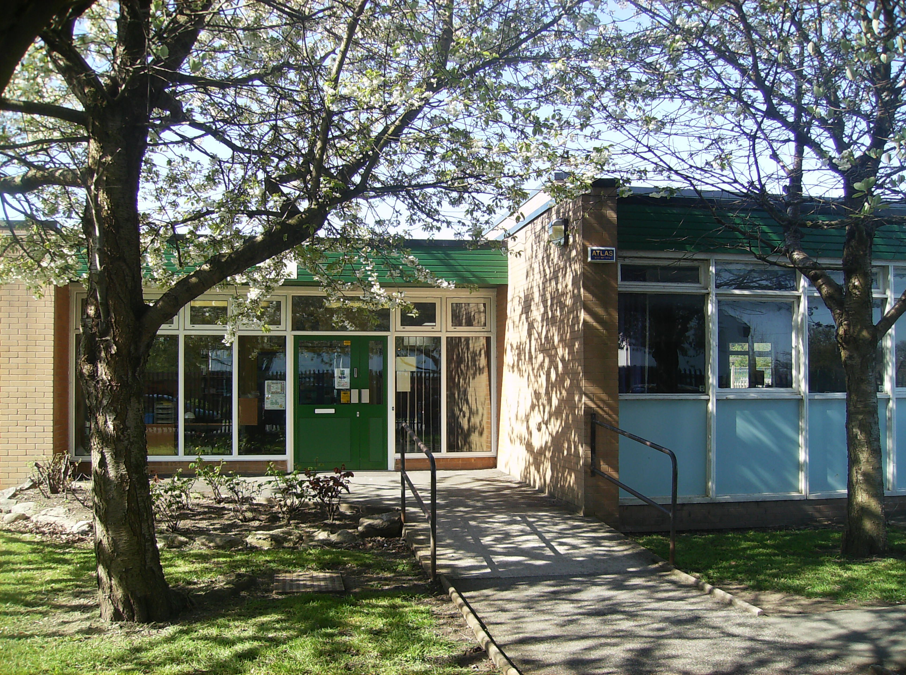

Charging Policy

Date: - 11th December 2012

HAYFIELD SCHOOL

CHARGING POLICY - SCHOOL ACTIVITIES

The governing body of Hayfield School has adopted the following policy in connection with the matter of charging for school activities.

- The governing body endorses the policy of the Wirral Local Authority (LA) with respect to charging for school activities. This policy is available from the school.

- Parents will be asked to pay in cash for materials which are being used in practical activities if they indicate a wish to own the finished product. Parents will be asked before the activity is undertaken whether they so wish.

- Parents may be asked for payment towards the cost of repairing or replacing any part of the fabric of the school or any item of school property which has been damaged or lost as a result of their child’s behaviour.

- Parents will be asked to pay for examination fees in the circumstances outlined in the Authority’s policy statement.

- School trips and visits form an important part of the curriculum offered by our school. Parents are not required to pay for such visits, but may be asked to make voluntary contributions towards their cost. No pupil will be excluded from a school trip because of their parents’ unwillingness or inability to contribute, but it is hoped that parents will feel able to support the school in its efforts to provide a full and interesting curriculum for all its pupils. If the contributions made are not sufficient to enable a planned trip to take place, the Headteacher may cancel the trip or make such changes to the organisation of the trip as he/she thinks necessary. Parents who have difficulty in meeting the full cost of a school trip may be assisted by the school.

- All trips and visits will be organised under the direction of the Headteacher and in accordance with the guidelines issued by LA (Circular 1/86). No school visit will take place without the approval of the governing body. Staff organising such trips will be responsible to the Headteacher at all times.

- Parents will be asked to meet the board and lodging costs of residential trips. Parents who have difficulty in meeting the full cost of a school visit may be assisted by the school.

- Parents may be charged for activities defined as “optional extras”, that is, activities which are provided mainly out of school hours and which are not part of the school curriculum. If parents would like their children to take part in such activities but are unable to meet the full cost, financial assistance may be available; the Headteacher is happy to talk to parents in confidence about that possibility.

- Music tuition is available to all pupils. There is a charge for the service provided by Wirral Schools Music Service which can be obtained by contacting the Wirral Schools Music Service directly..

- A “Schedule of Charges” will be compiled annually and agreed by the Governing Body. This will include any services provided by the school where a cost is incurred including school lunches & milk.

- Free meals may be given to visitors at the discretion of the Headteacher,

Taken to Finance Meeting dated ………………………………………………

Signed (Chair of Governors) ……………………………………………………

